**EXPERIMENT NO:-7**

**➢ AIM:** To design and test 1-bit Magnitude comparator.

**➢ APPARATUS:** Breadboard, jumpers wires, IC’s, LED’s, power supply.

**➢ THEORY:**

The 1 bit magnitude comparator is a combinational circuit that compares magnitude of  
two 4 bit numbers to make either of its O/P (A>B, A=B, A<B) at logic high level.  
Let A=A0 & B= B0 are 1-bit number respectively. The 1-bit magnitude comparator  
compares magnitudes as per following expressions for outputs.

Let xi will be at logic high level when Ai & Bi are at equal level. (i= 0, 1)

BLOCK DIAGRAM OF 1-BIT MAGNITUDE COMPARATOR:

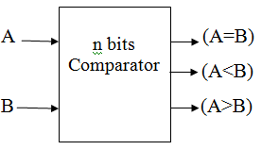

CIRCUIT DIAGRAM OF 1-BIT MAGNITUDE COMPARATOR:

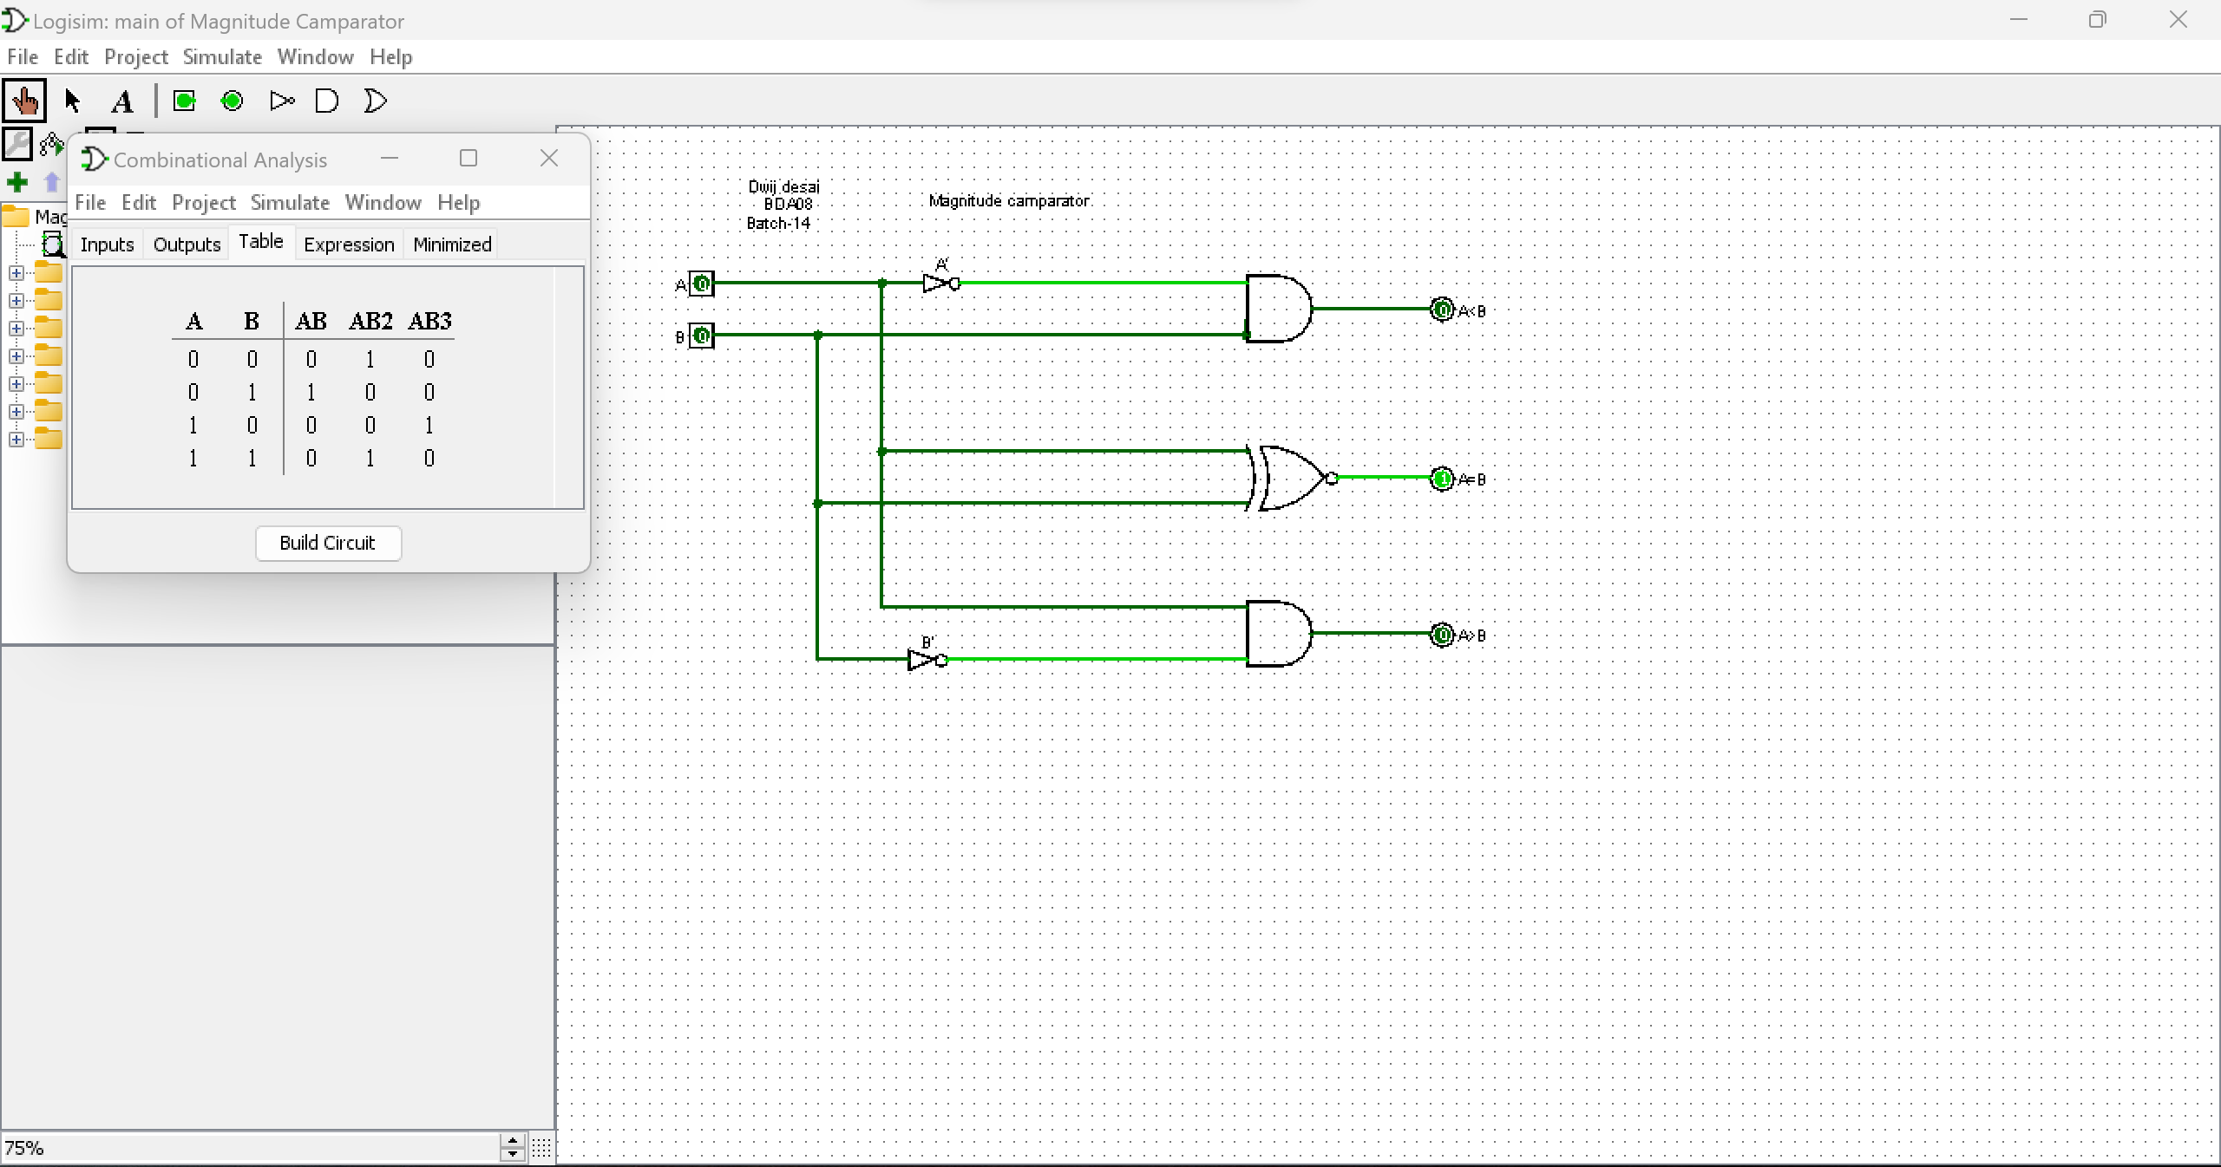

TRUTH TABLE

|  |  |  |  |  |
| --- | --- | --- | --- | --- |
| A | B | A<B | A=B | A>B |
| 0 | 0 | 0 | 1 | 0 |
| 0 | 1 | 1 | 0 | 0 |
| 1 | 0 | 0 | 0 | 1 |
| 1 | 1 | 0 | 1 | 0 |